**AB Testing Tool with Login and Dashboard**

AB Testing Tool with Login and Dashboard AB testing is a method of comparing two versions of a web page, landing page, or email message to determine which version performs better. It is a key tool in conversion optimization. The most common form of AB testing is the A/B test, which compares two versions of a page and measures which version performs better. This can be accomplished by displaying the same page twice, each time with a different version of the content.



Login and signup

Alternatively, a conversion funnel can be set up so that each visitor sees one version of the page, and the conversion rate is measured for each. In both cases, the test concludes after a predetermined number of visitors have seen each version.

Phase 1

1. Login Page
2. Dashboard
3. Camapign

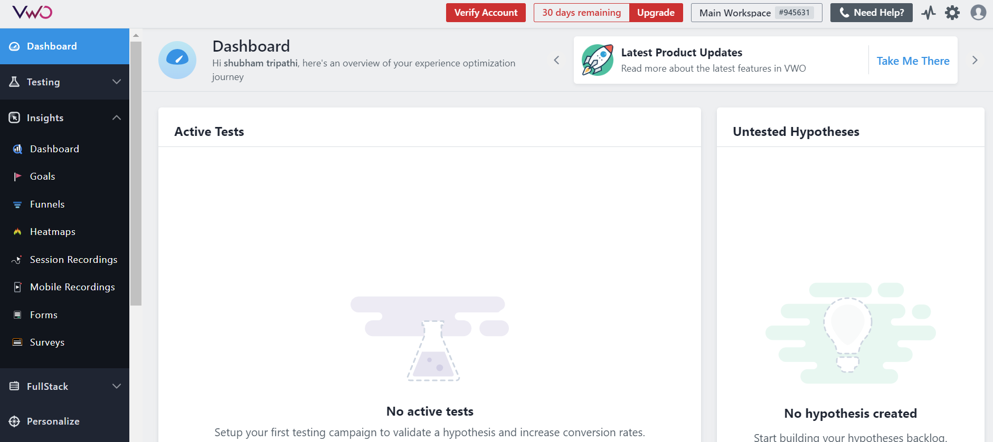

AB testing is an important part of conversion optimization because it helps determine what content resonates with your audience.

The following are the most common steps in an A/B test:

1. Decide what you want to test

2. Create two versions of the content (A and B)

3. Make sure both versions are live at the same time

4. Track conversions

5. Analyze results

ab testing tool - The ab testing tool is an excellent way to measure your abdominal muscles and determine which exercises are best for you. This simple device measures your body fat percentage, muscle mass and waist circumference to give you an accurate assessment of your fitness level.

Product Features: Portable, easy to use - Simply insert it into your underwear, stand up straight and press the button. Results will be displayed instantly on the screen.

Easy to understand results - The ab testing tool will tell you how much fat you have, how strong your abs are and how big your belly is compared to your height.Measure your progress - You can see your results over time to monitor any changes or improvements in your diet, exercise regime or weight loss plan.

Healthier you - Abdominal exercises such as crunches, sit ups and leg lifts work your core muscles which are vital for maintaining good posture and keeping your back healthy.